What is a Thane?

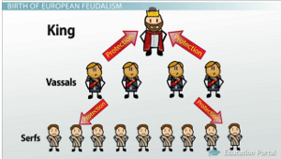

- To understand what the Thane of Glamis means, we must first know that a thane is.
- In the Middle Ages of Europe's past, areas of land would be ruled by kings who would allow certain noblemen to own portions of the land in exchange for their military service to the king.
- These noblemen were thanes. This entire system is known as feudalism. In the chart, a thane would be at or above the level of 'vassals,' who were land-holders who oversaw 'serfs' or non-landowners.
- In the play, Macbeth, by William Shakespeare, Macbeth is a Scotsman and a thane.
- At the beginning of the play, he is Thane of Glamis, Glamis simply being the name of the area Macbeth ruled over.
- After his success in battle, Macbeth became Thane of Cawdor as well (we'll look at how this happened shortly).
- So, thane is simply a title given to someone of nobility; you might compare it to the more modern-day term of 'duke.'

