English 3201 Name: ________________________

Wasps’ Nest (Quest text page 299)
A classic mystery story written by Agatha Christie, AKA the Queen of Crime.

Mystery stories:
- Build suspense
- Engage readers with a mystery, crime or puzzle that needs to be solved
- Leave gaps in the story that the reader has to fill in
- Use foreshadowing - hints the author gives readers about what it going to happen
- Give clues about the mystery, sometimes obvious, sometimes subtle
- Have red herrings, that is, false suspect(s) meant to lead readers to the wrong conclusion
- Have a reveal or twist in which the mystery, crime, or puzzle is solved.

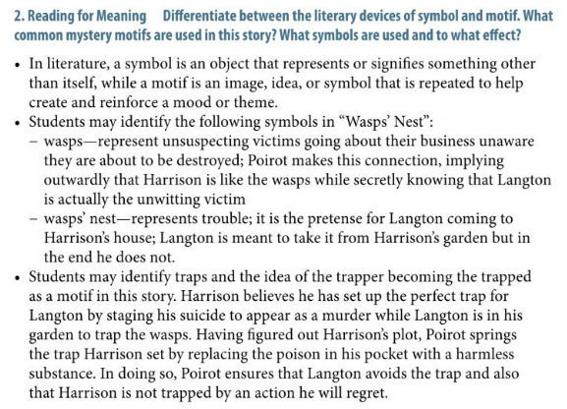

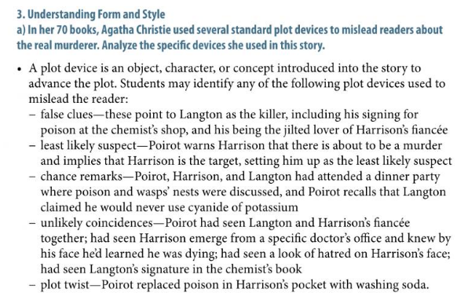

Complete the following questions after reading the story.

- Which point of view is used to tell the story?
  - First person
  - Second person
  - Third person limited
  - Third person omniscient

- What do we learn about John Harrison’s current situation from his description in the first paragraph?
  - He’s an avid gardener
  - He’s extremely wealthy
  - He’s led a hard life
  - He’s unusually happy

- What mood is developed in the second paragraph?
  - Calm
  - Expectant
  - Lonely
  - Suspenseful

- In the second paragraph, the line, “The rambler roses were still beautiful; sweet peas scented the air” is an example of this literary device.
  - Foreshadowing
  - Imagery
  - Metaphor
  - Simile

- What is Harrison’s initial reaction to discovering his unexpected visitor is Monsieur Poirot?
  - Fake happiness
  - Genuine happiness
  - Hidden fear
  - Sudden doubt

- Who was Miss Molly Deane engaged to first?
  - Claude Langdon
  - John Harrison
  - Monsieur Poirot
  - The chemist in Barchester

- The story Poirot shares about once knowing a pickpocket is an example of this.
  - Allegory
  - Allusion
  - Anecdote
  - Flashback

- Identify two motives behind Hercule Poirot’s visit to John Harrison. How do these motives help develop/reveal the detective’s character? (6 marks)

- Explain the significance of the title, making reference to both its literal and symbolic meaning. (6 marks)

- What moral lessons does the author deliver in this story? Through which character does she deliver these messages? (6 marks)

