1201 Practice Visual Booklet
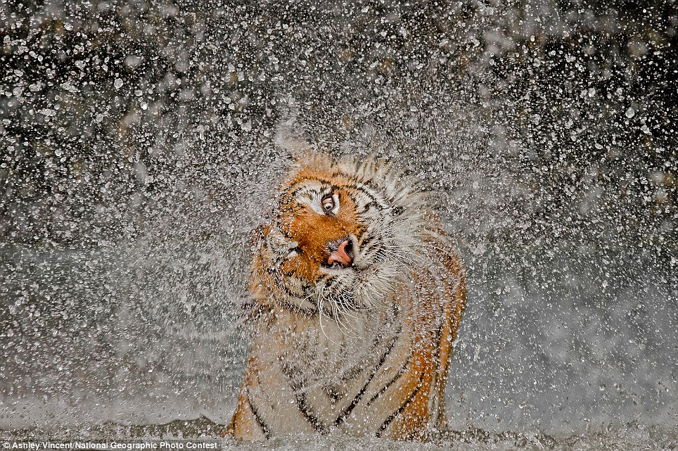

- This visual BEST illustrates which of the following elements?

- Balance
- Focal Point
- Perspective
- Value

- What is the form of the visual?

- Advertisement
- Brochure
- Collage
- Photograph

- How is movement created in this visual? Explain using reference to a visual element from the image.

__________________________________________________________________________________________________________________________________________________________________________________________________________________________________________________________________________________________________________________________________________________________________________________________________________________________________________________________________________________________________________________________________________________________________________________________________________________________________________________________________________________________________________________________________________________________________________________________________________________________________________________________________________________________

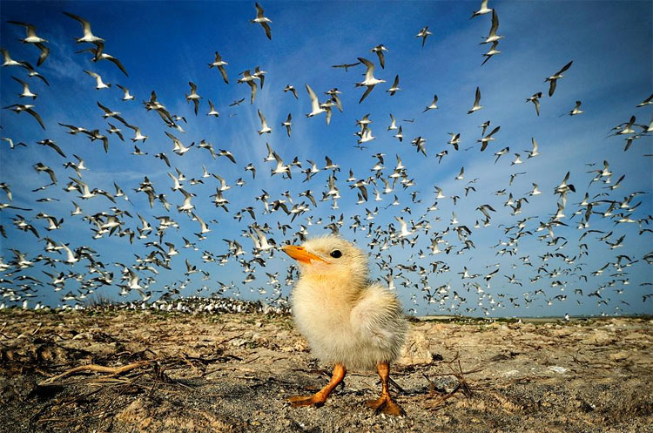

- Shapes are repeated throughout this visual. To which aspect of the visual does this contribute?

- Harmony
- Proportion
- Texture
- Value

- What technique has been employed by the artist to create depth?

- Blank space
- Contrast
- Hue
- Perspective

- In this visual, proportion is:

- Asymmetrical
- Balanced
- Exaggerated
- Realistic

- The BEST technique which creates the realistic look of the feathers and ground is created through capturing the objects

a. Composition
b. Light
c. Shape
d. Texture

- What is the focal point in this visual, and how is it created. Explain your answer using reference to two visual elements.

________________________________________________________________________________________________________________________________________________________________________________________________________________________________________________________________________________________________________________________________________________________________________________________________________________________________________________________________________________________________________________________________________________________________________________________________________________________________________________

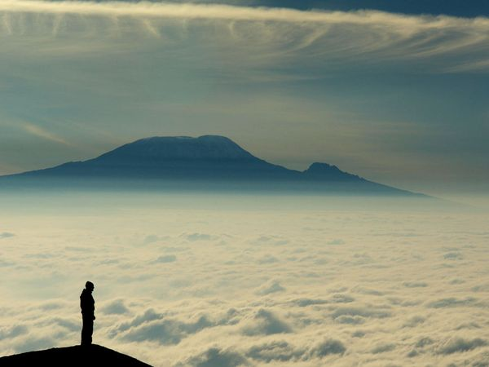
- In this visual, distance is BEST created through

- Lighting
- Line
- Scale
- Shadow

- The black silhouette of the man placed against the white clouds creates:

a. Contrast
b. Hue
c. Space
d. Value

- What could a potential message be for this piece? Discuss using two visual elements as references.

__________________________________________________________________________________________________________________________________________________________________________________________________________________________________________________________________________________________________________________________________________________________________________________________________________________________________________________________________________________________________________________________________________________________________________________________________________________________________________________________________________________________________________________________________________________________________________________________________________________________________________________________________________________________

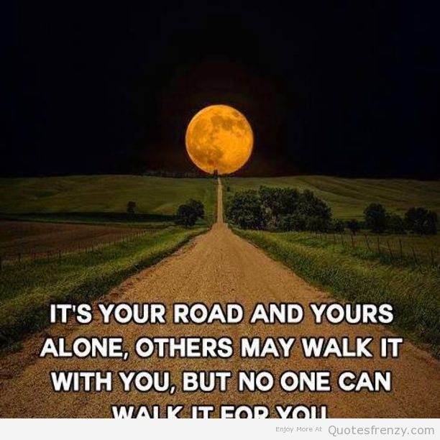

- How is balance created in this visual? Discuss with two references to the image.

________________________________________________________________________________________________________________________________________________________________________________________________________________________________________________________________________________________________________________________________________________________________________________________________________________________________________________________________________________________________________________________________________________________________________________________________________________________________________________
- Write a brief narrative essay (300-400 words) relating this message to your own life.
____________________________________________________________________________________________________________________________________________________________________________________________________________________________________________________________________________________________________________________________________________________________________________________________________________________________________________________________________________________________________________________________________________________________________________________________________________________________________________________________________________________________________________________________________________________________________________________________________________________________________________________________________________________________________________________________________________________________________________________________________________________________________________________________________________________________________________________________________________________________________________________________________________________________________________________________________________________________________________________________________________________________________________________________________________________________________________________________________________________________________________________________________________________________________________________________________________________________________________________________________________________________________________________________________________________________________________________
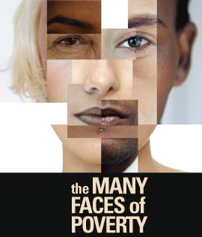

- What overall purpose does the visual serve? Support your answer with two references to the image.

____________________________________________________________________________________________________________________________________________________________________________________________________________________________________________________________________________________________________________________________________________________________________________________________________________________________________________________________________________________________________________________________________________________________________________________________________________________________________________________________________________________________________________________________________________________________________________________________________________

- What is the main tone expressed in this piece? Support your answer using two references to the visual.
__________________________________________________________________________________________________________________________________________________________________________________________________________________________________________________________________________________________________________________________________________________________________________________________________________________________________________________________________________________________________________________________________________________________________________________________________________________________________________________________________________________________________________________________________________________________________________________________________________________________________________________________________________________________

Who will be next?

- The contrasting features of this visual are created through a technique called

a. Composition
b. Frame
c. Juxtaposition
d. Tension

- Who could be a potential target audience? Support your answer with two references to elements from the visual.

________________________________________________________________________________________________________________________________________________________________________________________________________________________________________________________________________________________________________________________________________________________________________________________________________________________________________________________________________________________________________________________________________________________________________________________________________________________________________________

- Explain the irony that can be found in this visual. Make two references to the visual to support your answer.

______________________________________________________________________________________________________________________________________________________________________________________________________________________________________________________________________________________________________________________________________________________________________________________________________________________________________________________________________________________________________________________________________________________________________________________________________________________________________________________________________________________________________________________________________________________________________________________________________________________________________________________________________________________________________________________________________________________________________________________________________________________________________________________

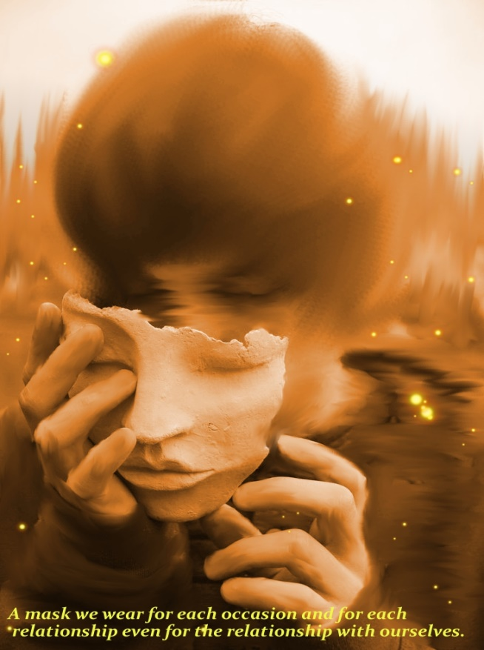
19. The technique of blurring the background of the photo is playing with the

- Bordering
- Composition
- Focus
- Rule of thirds

20. What is the function of the mask in this image? Discuss using two references to the visual.

________________________________________________________________________________________________________________________________________________________________________________________________________________________________________________________________________________________________________________________________________________________________________________________________________________________________________________________________________________________________________________________________________________________________________________________________________________________________________________

21. In 350 words, write a journal entry about a time when you felt this visual represented your experiences as an adolescent.
________________________________________________________________________________________________________________________________________________________________________________________________________________________________________________________________________________________________________________________________________________________________________________________________________________________________________________________________________________________________________________________________________________________________________________________________________________________________________________
________________________________________________________________________________________________________________________________________________________________________________________________________________________________________________________________________________________________________________________________________________________________________________________________________________________________________________________________________________________________________________________________________________________________________________________________________________________________________________
____________________________________________________________________________________________________________________________________________________________

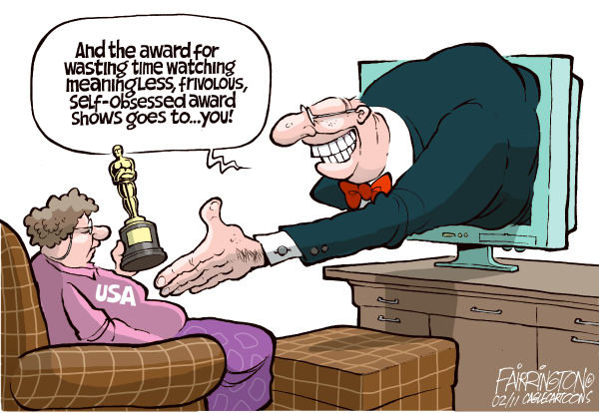
22. What is the main message of this visual? Explain.

__________________________________________________________________________________________________________________________________________________________________________________________________________________________________________________________________________________________________________________________________________________________________________________________________________________________________________________________________________________________________________________________________________________________________________________________________________________________________________________________________________________________________________________________________________________________________________________________________________________________________________________________________________________________

23. What word best represented the tone of the visual? Explain.

______________________________________________________________________________________________________________________________________________________________________________________________________________________________________________________________________________________________________________________________________________________________________________________________________________________________________________________________________________________________________________________________________________________________________________________________________________________________________________________________________________________________________________________________

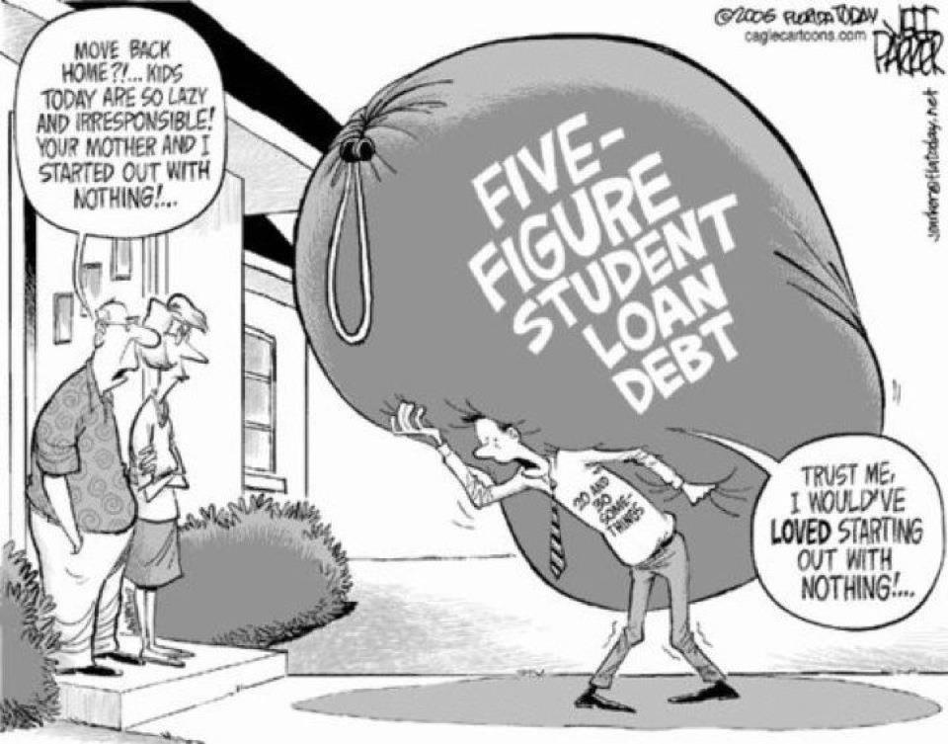

24. What is the MAIN function of the bag in the visual?

- Blank space
- Emphasis
- Proportion
- Symbol

25. Who is the target audience? Support your answer with two references to elements from the visual.
______________________________________________________________________________________________________________________________________________________________________________________________________________________________________________________________________________________________________________________________________________________________________________________________________________________________________________________________________________________________________________________________________________________________________________________________________________________________________________________________________________________________________________________________
26. What overall purpose does the visual serve? Support your answer with two references to the image.

______________________________________________________________________________________________________________________________________________________________________________________________________________________________________________________________________________________________________________________________________________________________________________________________________________________________________________________________________________________________________________________________________________________________________________________________________________________________________________________________________________________________________________________________

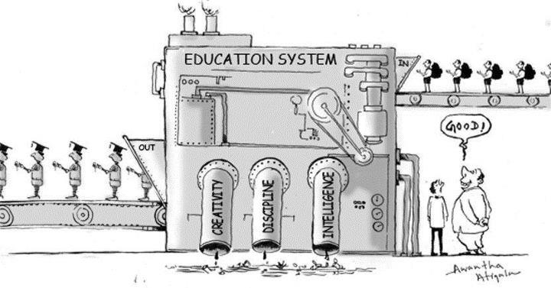

27. What does machine represent? How does it create a message? Explain with at least two references to the visual.

______________________________________________________________________________________________________________________________________________________________________________________________________________________________________________________________________________________________________________________________________________________________________________________________________________________________________________________________________________________________________________________________________________________________________________________________________________________________________________________________________________________________________________________________
____________________________________________________________________________________________________________________________________________________________

28. In your opinion, does this visual accurately represent the education system today? Explain your reasoning with reference to your personal experiences in school.

______________________________________________________________________________________________________________________________________________________________________________________________________________________________________________________________________________________________________________________________________________________________________________________________________________________________________________________________________________________________________________________________________________________________________________________________________________________________________________________________________________________________________________________________
______________________________________________________________________________________________________________________________________________________________________________________________________________________________________________________________________________________________________________________________________________________________________________________________________________________________________________________________________________________________________________________________________________________________________________________________________________________________________________________________________________________________________________________________

