English 1201: Poetry and Visuals Unit

Use questions found on terms handouts for analysis.

Completed: Beyond Pastel, Phenomenal Woman with Short Story Unit

- Patrick Roche – “21” (Cupsi 2014) – http://youtube.com/watch?v=6LnMhy8DiQ

21.

My father is run over by a car.

He is passed out in the road with a blood alcohol content

4 times the legal limit.

I do not cry.

Four months later,

The nurses lose his pulse,

And I wonder whose life

Flashed before his eyes.

Rewinding VHS tapes

Old home videos

20.

19.

I haven’t brought a friend home in four years.

18.

My mother sips the word “divorce”

Her mouth curls at the taste.

17.

I start doing homework at Starbucks.

I have more meaningful conversations with the barista

Than with my family.

16.

I wait for Christmas Eve.

My brother and I usually exchange gifts to one another early

This year, he and my father exchange blows.

My mother doesn’t go to mass.

15.

I come up with the theory that my father started drinking again

Because maybe he found out I’m gay.

Like if he could make everything else blurry,

Maybe somehow I’d look straight.

15.

My mother cleans up his vomit in the middle of the night

And cooks breakfast in the morning like she hasn’t lost her appetite.

15.

I blame myself.

15.

My brother blames everyone else.

15.

My mother blames the dog.

15.

Super Bowl Sunday

My father bursts through the door like an avalanche

Picking up speed and debris as he falls

Banisters, coffey tables, picture frames

Tumbling, stumbling.

I find his AA chip on the kitchen counter.

14.

My father’s been sober for 10

Maybe 11, years?

I just know

We don’t even think about it anymore.

13.

12.

11.

Mom tells me daddy’s “meetings” are for AA.

10.

My parents never drink wine at family gatherings.

All my other aunts and uncles do.

I get distracted by the TV and forget to ask why.

9.

8.

7.

6.

I want to be Spider-Man.

Or my dad.

They’re kinda the same.

5.

4.

3.

I have a nightmare,

The recurring one about Ursula from the The Little Mermaid

So I get uo

I waddle toward Mommy and Daddy’s room,

Blankie in hand,

I pause.

Daddy’s standing in his underwear

Silhouetted by refrigerator light.

He raises a bottle

To his lips.

2.

1.

Zero. When my mother was pregnant with me,

I wonder if she hoped,

As so many mothers do,

That her baby boy would grow up to be

Just like

His father.

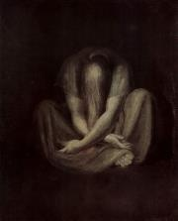

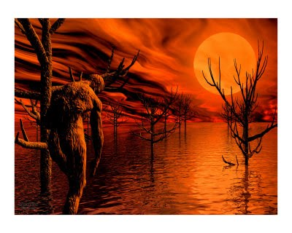

- Dulce Et Decorum Est and And He Said Fight On (textbook)

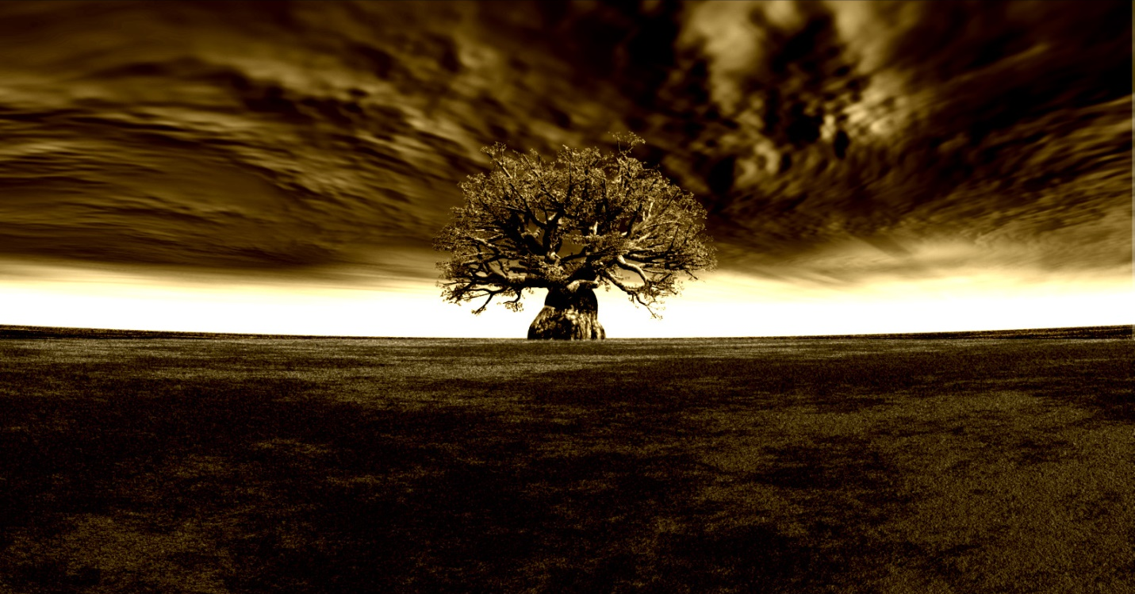

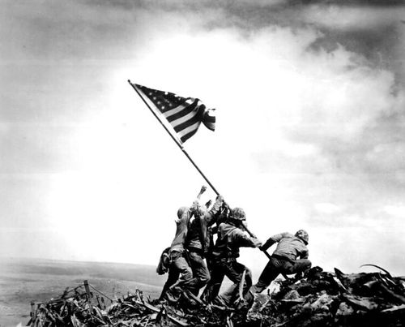

- Shane Koyczan – “Troll” - http://www.youtube.com/watch?v=670if6Etx0o

Troll
Once upon a time, you and all your kind
lived underneath bridges
had ridges for ribs that dropped off into empty chests
as if your hearts were all stolen treasures
as if an excavation crew were hired to dig up and remove the part of you that let you feel
and while the world above you invented the wheel you stayed put
knowing that would one day roll over top of you to get to where it's going
you had an endlessly flowing supply line of food
you began to brood over humanity and made meals of our hope
as if crushing our spirits would make your mirrors cast better reflections than the ones they gave
as if the only way you could save yourselves was to make the world ugly so no one would notice you hided in it
you learned to knit pain into a kind of camouflage
treated hope like a mirage that you could use to lure in your next meal
you lived off our fears, you could taste what we feared
and every night, as the moon at bedtime stories on sunlight
you took darkness as an invite to head out into the woods
you curled your hands into wrecking balls
your breath became squalls, you made rocks rumble,
you made land shiver, you made boys and girls pray that someone would deliver them from you
we told them, you aren't real
and then one day, the world changed
but you all stayed the same
just migrated from living underneath bridges to living underneath information superhighways
days and nights became meaningless, each already deep in chest became an abyss no one would ever find the bottom of
concepts like love fell into your gravity
we turned ourselves into life preservers hoping to save as many as we could
but the fathers who guarded closet doors and the mothers who secured the floors under beds all shook their heads not knowing how to deal with you
you, who crept into our lives, with tongues like knifes stabbing your words into our skin
you began to begin uploading yourselves into our homes
you had computer screens for eyes and software for bones
you turned your hate into stones
and hurled them at beauty, as if you couldn't bear to see anything other than ugly
anything different
you had fingernails like flint and scraped them against decency hoping we would be the ones to all catch fire
you all had smiles like one-way barbed wire not meant to keep us out, but to keep us in
always like a firing pin, you spoke in explosions
it isn't cute
it isn't funny
you talked strangers into death
and laughed
and as each family learns to graft skin over the wounds you gave them, you helm yourself into the scar
you have coaxed the sober back into bars, handed out cigars at memorials
offered nooses, cliffs, and pills to those who unfortunately found you before they found help
you praised suffering
waltzed in between tragedies, gracefully dipping miseries as if we would be somehow impressed by the dexterity of your animosity
you cheered on, right?
dashed through police tape as if it were the finish line in a race on who could be awful first
even now
you somehow see this as an invitation to turn your keyboards into catapults
wondering which one of you can be the first to hate us best
your loathing
already dressed in riot gear
ready to incite rage
as if each message board is a stage who you recite hostility turning freedom of speech into freedom of cruelty
we are stuck with you
the same way you are stuck with you
your mind is glue and it keeps malice fastened there like cheap wallpaper
we were once upon a time told that none of you exist
we dismissed you as make believe or myth, now
on only with resolve
we can no longer afford to tell ourselves, that you aren't real
we will not let you make your dinners out of the things we feel.

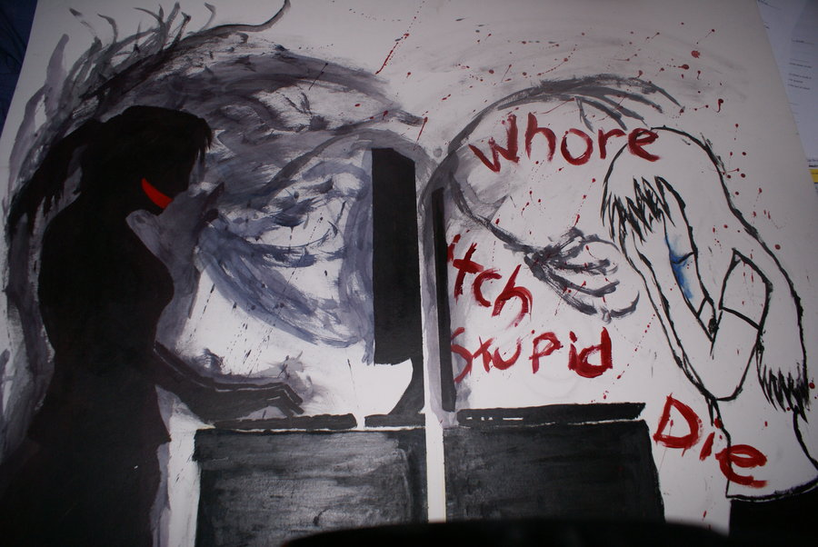

- I Will Not Let An Exam Result Decide My Fate - http://www.youtube.com/watch?v=D-eVF_G_p-Y
- On Unmaking Contact (Textbook) p.246, Sifter (Textbook) p.247, Life (Textbook) p. 248

