English 1201: Poetry and Visuals Unit

Patrick Roche – “21” (Cupsi 2014) – http://youtube.com/watch?v=6LnMhy8DiQ

21.

My father is run over by a car.

He is passed out in the road with a blood alcohol content

4 times the legal limit.

I do not cry.

Four months later,

The nurses lose his pulse,

And I wonder whose life

Flashed before his eyes.

Rewinding VHS tapes

Old home videos

20.

19.

I haven’t brought a friend home in four years.

18.

My mother sips the word “divorce”

Her mouth curls at the taste.

17.

I start doing homework at Starbucks.

I have more meaningful conversations with the barista

Than with my family.

16.

I wait for Christmas Eve.

My brother and I usually exchange gifts to one another early

This year, he and my father exchange blows.

My mother doesn’t go to mass.

15.

I come up with the theory that my father started drinking again

Because maybe he found out I’m gay.

Like if he could make everything else blurry,

Maybe somehow I’d look straight.

15.

My mother cleans up his vomit in the middle of the night

And cooks breakfast in the morning like she hasn’t lost her appetite.

15.

I blame myself.

15.

My brother blames everyone else.

15.

My mother blames the dog.

15.

Super Bowl Sunday

My father bursts through the door like an avalanche

Picking up speed and debris as he falls

Banisters, coffey tables, picture frames

Tumbling, stumbling.

I find his AA chip on the kitchen counter.

14.

My father’s been sober for 10

Maybe 11, years?

I just know

We don’t even think about it anymore.

13.

12.

11.

Mom tells me daddy’s “meetings” are for AA.

10.

My parents never drink wine at family gatherings.

All my other aunts and uncles do.

I get distracted by the TV and forget to ask why.

9.

8.

7.

6.

I want to be Spider-Man.

Or my dad.

They’re kinda the same.

5.

4.

3.

I have a nightmare,

The recurring one about Ursula from the The Little Mermaid

So I get up

I waddle toward Mommy and Daddy’s room,

Blankie in hand,

I pause.

Daddy’s standing in his underwear

Silhouetted by refrigerator light.

He raises a bottle

To his lips.

2.

1.

Zero. When my mother was pregnant with me,

I wonder if she hoped,

As so many mothers do,

That her baby boy would grow up to be

Just like

His father.

Visual #1:

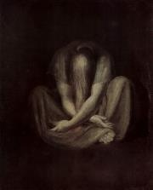

Visual #2:

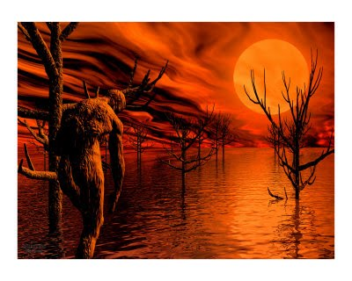

Questions: Complete for homework

1. State an appropriate tone for the speaker in this poem. Show how this tone is developed with two references to the text (hint: tone is developed through word choice and phrasing, repetition, etc.).

2. State the main symbol of this poem. What does it symbolize? How is it effective in this poem?

3. Discuss how the use of color and line is used effectively in visual #1. Use two references to the visual.

4. State a title for visual #2. Defend, using two specific references to the visual, why your title is appropriate.

