Mending Wall
Robert Frost, 1874 - 1963

Something there is that doesn’t love a wall,
That sends the frozen-ground-swell under it,
And spills the upper boulders in the sun;
And makes gaps even two can pass abreast.
The work of hunters is another thing:
I have come after them and made repair
Where they have left not one stone on a stone,
But they would have the rabbit out of hiding,
To please the yelping dogs. The gaps I mean,
No one has seen them made or heard them made,
But at spring mending-time we find them there.
I let my neighbor know beyond the hill;
And on a day we meet to walk the line
And set the wall between us once again.
We keep the wall between us as we go.
To each the boulders that have fallen to each.
And some are loaves and some so nearly balls
We have to use a spell to make them balance:
‘Stay where you are until our backs are turned!'
We wear our fingers rough with handling them.
Oh, just another kind of outdoor game,
One on a side. It comes to little more:
There where it is we do not need the wall:
He is all pine and I am apple orchard.
My apple trees will never get across
And eat the cones under his pines, I tell him.
He only says, ‘Good fences make good neighbors.'
Spring is the mischief in me, and I wonder
If I could put a notion in his head:
'Why do they make good neighbors? Isn’t it
Where there are cows? But here there are no cows.
Before I built a wall I’d ask to know
What I was walling in or walling out,
And to whom I was like to give offense.
Something there is that doesn’t love a wall,
That wants it down.' I could say ‘Elves’ to him,
But it’s not elves exactly, and I’d rather
He said it for himself. I see him there
Bringing a stone grasped firmly by the top
In each hand, like an old-stone savage armed.
He moves in darkness as it seems to me,
Not of woods only and the shade of trees.
He will not go behind his father’s saying,
And he likes having thought of it so well
He says again, ‘Good fences make good neighbors.'

Questions: Answer for HOMEWORK if they aren’t finished in class!

1. What is the major symbol found in this poem? What does it symbolize? How is this symbol being used to develop a theme? Explain with two references to the poem.

2. What literary devices are being used throughout the poem? Underline and label them in the poem above.

THE FALL OF THE BERLIN WALL

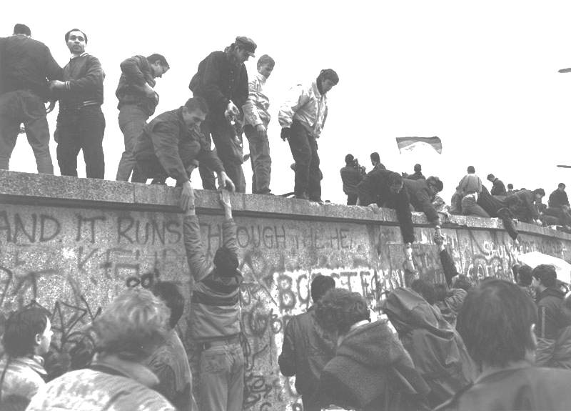
3. Discuss how the statement “Good walls make good neighbours” from “Mending Wall” is not applicable to the above image. Use your class discussion and the jot notes below to complete this answer.
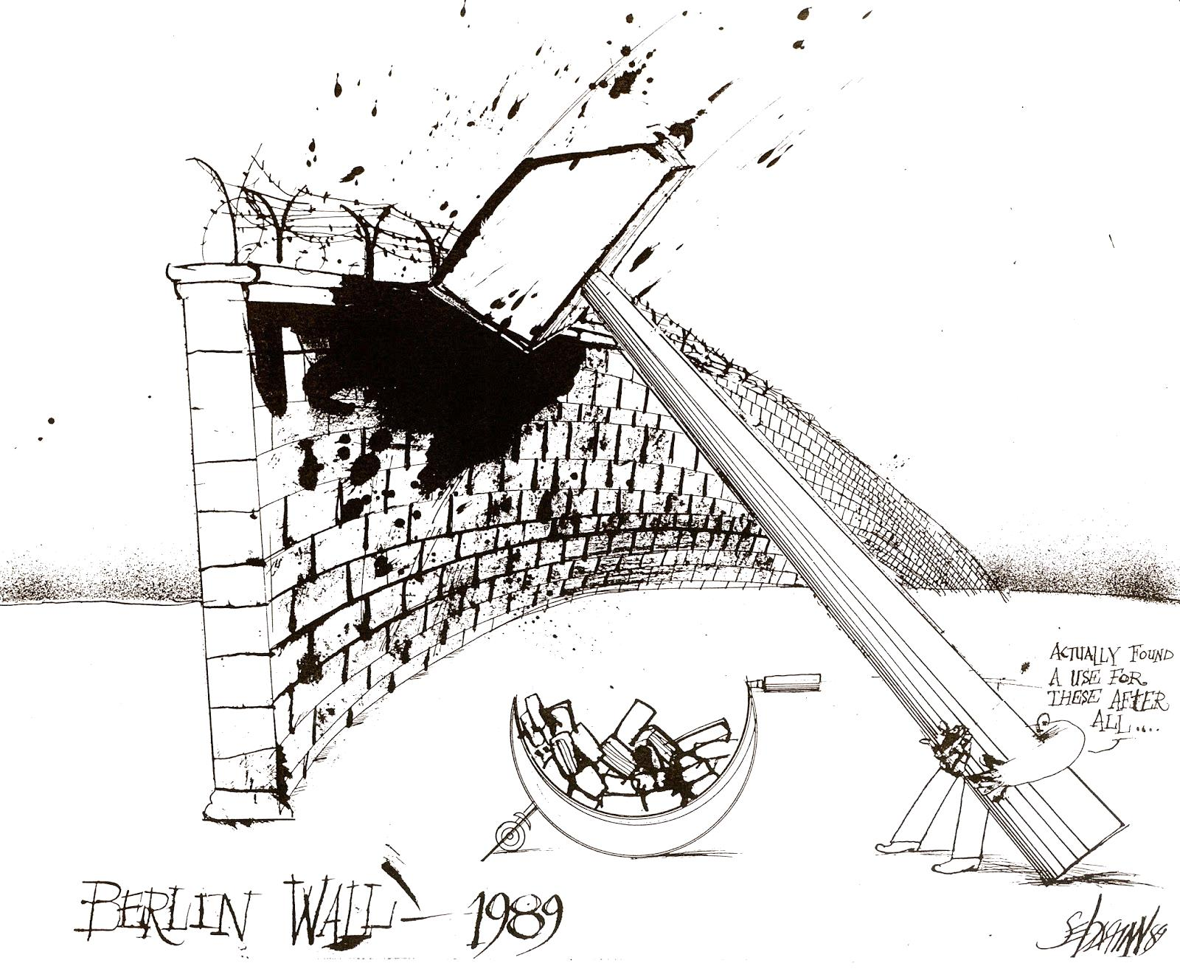
4. What effect does proportion and symbolism have in this visual? Explain using two specific references.
Jot Notes:
*Russian Communism – Founded circa 1912 by Vladimir Lenin; Party was dissolved in 1991 and Gorbachev was the final leader
*Communism spread across Eastern Europe (a domineering and oppressive political system). Communists opposed the ideals of capitalism (working for individual benefit); instead citizens worked to benefit the state. Equality was idealized.
*Berlin wall was erected in 1961 to separate East (communist) and West Berlin. It heavily restricted movement between the halves of the city (tearing families apart). Emigration was not permitted. The people of East Berlin were desperate but could not fight against the German Democratic Republic (those responsible for the wall)
*The hammer and sickle were the symbols on the communist flag (created during the Russian Revolution).The hammer stood for industrial labourers and the sickle for the peasantry. Combined as they were on the flag they represented the worker-peasant alliance for socialism. After the Russian Civil War the hammer and sickle become symbolic of peaceful labour within the Soviet Union.

