1.
Create a title for this visual. Use at least two visual elements to show how this title is appropriate.
Using specific references, explain how the artist has used two elements effectively to convey message.

2. 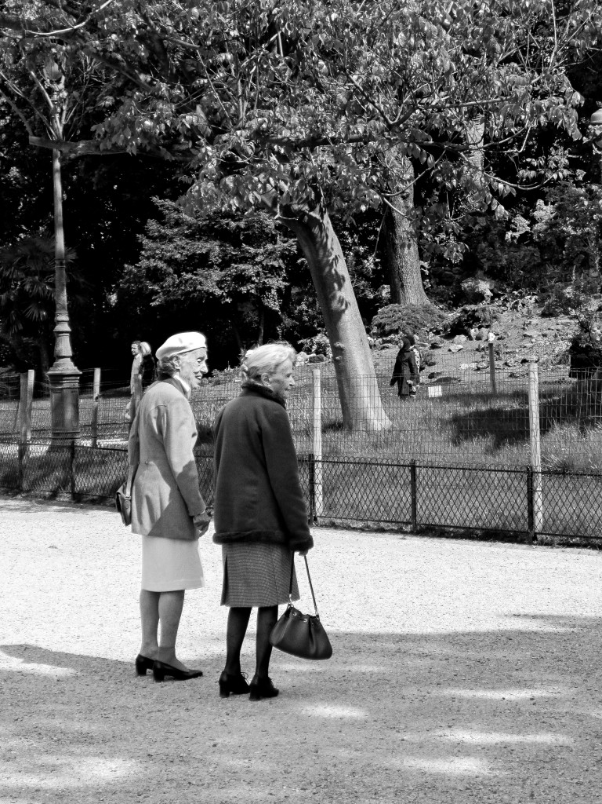
Discuss how the use of two visual elements in the visual are particularly effective.

3.
Using two specific references, explain how the artist has used visual elements effectively to convey message.

4.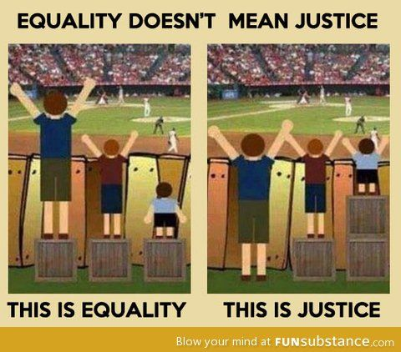
What is the tone created in this visual? Explain your answer with two references to the visual.
Discuss how the use of two visual elements in the visual are particularly effective.

5. 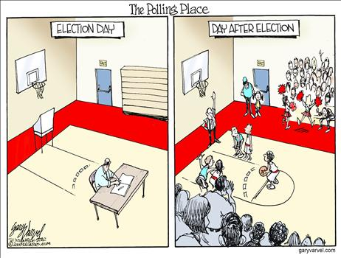
What is the tone created in this visual? Explain your answer with two references to the visual.
Who is a possible target audience for this visual? Support your answer with two references to the visual.

6. 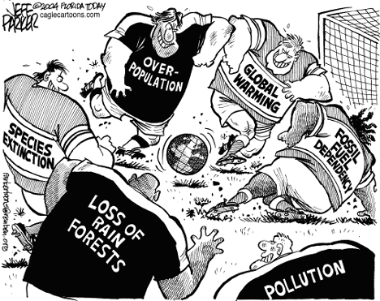
Using two specific references, explain how the artist has used both visual and textual elements effectively to convey message.
Who is a possible target audience for this visual? Support your answer with two references to the visual.

7.
Discuss how the use of two visual elements in the visual are particularly effective.

