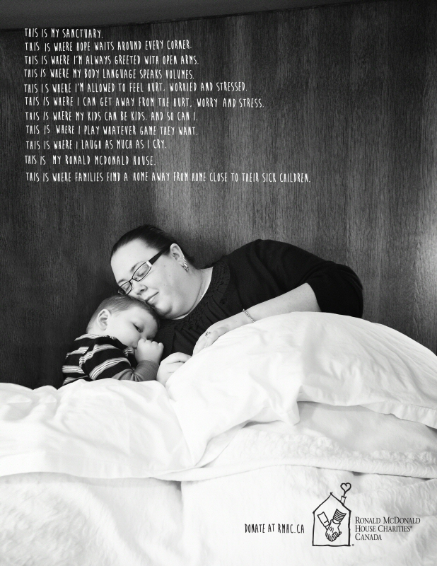
- Who is the intended audience in this visual? (1 mark)
- charity donors
- hospital workers
- large corporations
- sick children
- What is the purpose of repeating the phrase, “This is where…” throughout the visual? (1 mark)
- to create emphasis
- to encourage dialogue
- to identify stereotype
- to provide comic relief
- In the context of the visual, what does the word “sanctuary” (line 1) mean? (1 mark)
- chapel
- mission
- purpose
- dwelling
- What is the dominant media strategy used? (1 mark)
- celebrity endorsement
- facts and figures
- plain folks
- shock appeal
Constructed Response (6 marks)
- With specific references, explain how two visual elements contribute to the overall message of the visual.


- What is the purpose of the hand coming out of the snow? (1 mark)
- create balance
- demonstrate contrast
- imply scale
- reinforce message
- What best describes the purpose of the visual? (1 mark)
- advertise
- critique
- entertain
- scare
- What is the visual promoting? (1 mark)
- cell phones
- phone cases
- weather patterns
- winter preparedness
- In the context of the visual, what does the word “resilient” mean? (1 mark)
- delicate
- elastic
- tough
- weak
Constructed Response
- With reference to two specific visual elements, identify the atmosphere created in the visual (6 marks)



- What is the focal point of the visual? (1 mark)
- girl’s mouth
- her eyes
- Listerine breath tabs
- “No one needs to know” text
- What mood is created in the visual? (1 mark)
- amused
- content
- hostile
- serious
- What is the form of the visual? (1 mark)
- advertisement
- brochure
- poster
- web page
- What is suggested by the police tape over the girl’s mouth?
- A crime has been committed.
- She has bad breath.
- Using Listerine should be confidential.
- Fresh breath is attained with Listerine.
Constructed Response
- With specific references, explain how two visual elements contribute to the overall message of the visual. (6 marks)

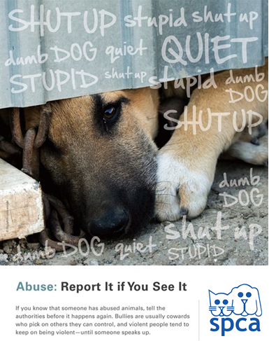

- Who is the intended audience of the visual? (1 mark)
- bullies
- dog owners
- general public
- SPCA
- What is the purpose of this visual? (1 mark)
- to advertise an organization
- to encourage adoption
- to provoke debate
- to raise awareness
- What is the tone of the visual? (1 mark)
- adoring
- enraged
- impartial
- unsympathetic
- What is the purpose of the dash in the phrase, “... and violent people tend to keep on being violent – until someone speaks up.”? (1 mark)
- to create suspense
- to provide a transition
- to establish mood
- to emphasize pause
Constructed Response (6 marks)
- With reference to two specific visual elements, explain the purpose of the text in the visual. (6 marks)

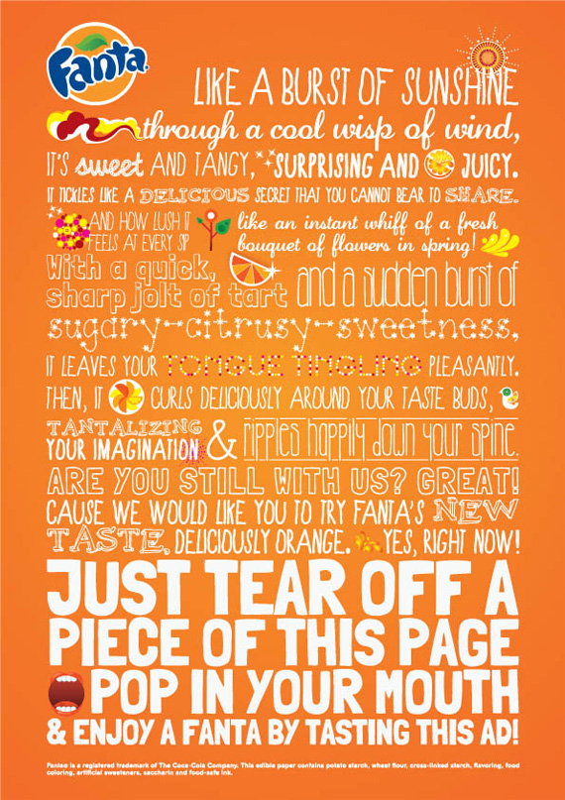

- What writing style is mainly used in this visual? (1 mark)
- argumentation
- description
- exposition
- persuasion
- Which device is evident in, “Are you still with us?” (1 mark)
- conflict
- hyperbole
- parallel structure
- rhetorical question
- What device is evident in “Like a burst of sunshine through a cool wisp of wind,”? (1 mark)
- alliteration
- metaphor
- oxymoron
- personification
- What device is evident in “It leaves your tongue tingling pleasantly.”? (1 mark)
- euphony
- onomatopoeia
- paradox
- simile
Constructed Response
- Using two specific references identify and explain the mood of the visual. (6 marks)

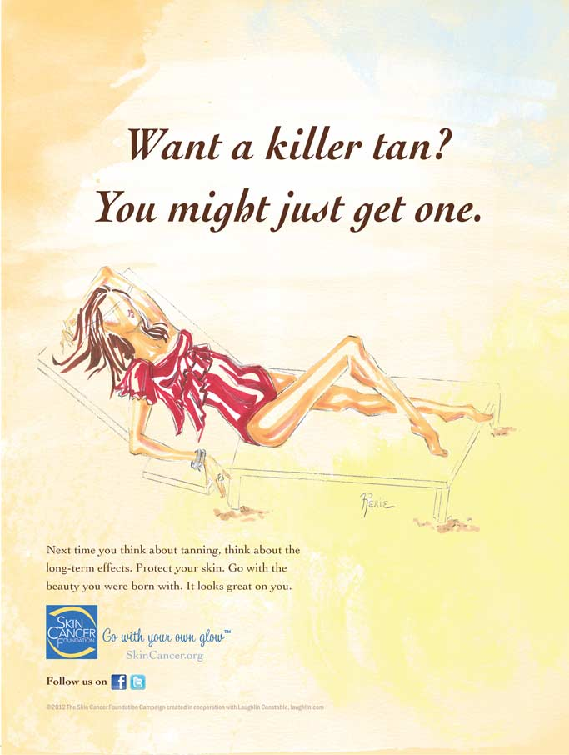

- What is the purpose of using short sentences throughout the visual? (1 mark)
- create emphasis
- demonstrate contrast
- establish audience
- imply stereotype
- Who is the sponsor? (1 mark)
- Cancer Foundation
- Facebook
- SkinCancer.org
- Twitter
- What is implied by the statement, “Want a killer tan? You might just get one.”? (1 mark)
- Long term tanning can cause major health problems.
- Moderate sun exposure is acceptable.
- Tanning will make you look and feel good.
- Wearing sunscreen prevents skin cancer.
- What is the purpose of the visual? (1 mark)
- to criticize
- to entertain
- to inform
- to reflect
Constructed Response
- Using two specific references identify and explain the tone of the visual. (6 marks)


- What is the purpose of the line, “Bring home a HERO for the holidays.”? (1 mark)
- to ask a question
- to describe the holidays
- to give a command
- to promote physical activity
- Why is the word HERO capitalized? (1 mark)
- advertise vacation options
- emphasize the importance of holidays
- promote the product
- stress snowboarding safety
- What is achieved by the use of juxtaposition in the visual?
- to create comparison
- to create perspective
- to establish exaggeration
- to establish focal point
- What literary device is used in, “Because you never know when they’ll GoPro”? (1 mark)
- alliteration
- oxymoron
- pun
- symbolism
Constructed Response
- Using two references, what is the connotation in the visual? (6 marks)


- What is the form? (1 mark)
- brochure
- collage
- poster
- webpage
- What is the focal point of the visual? (1 mark)
- letter block
- gun
- text
- web address
- What device is used in the text, “Education Opportunity Justice”? (1 mark)
- cliché
- imagery
- parallelism
- symbolism
- What technique best develops the message? (1 mark)
- background
- balance
- scale
- symmetry
Constructed Response
- With reference to two visual elements, identify the intended audience. (6 marks)

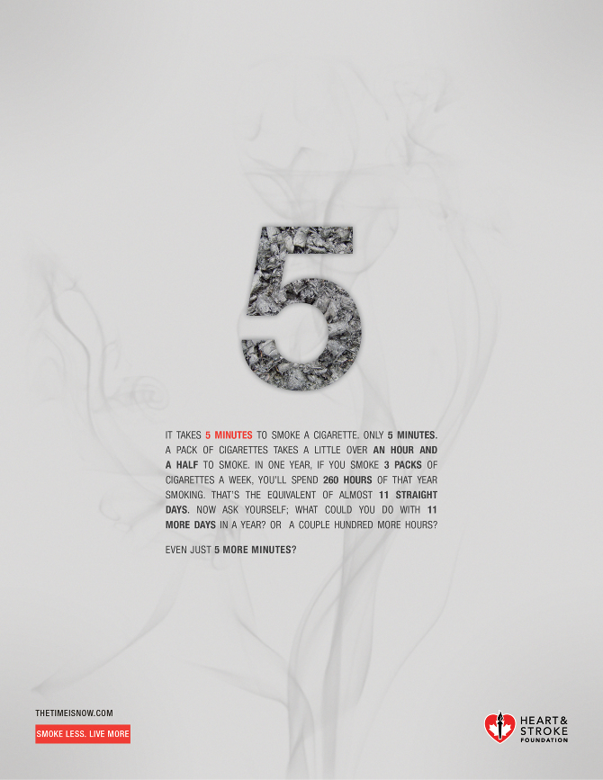

- What media strategies are use in the visual? (1 mark)
- celebrity endorsement and bandwagon
- celebrity endorsement and shock appeal
- facts and figures and shock appeal
- facts and figures and snob appeal
- What line best exemplifies the message? (1 mark)
- Even just 5 more minutes?
- Heart and Stroke Foundation
- Smoke Less. Live More
- Thetimeisnow.com
- What is the dominant literary device in the visual? (1 mark)
- paraphrase
- rhetorical question
- sentence fragment
- transition
- What is the purpose of the bold text throughout the visual? (1 mark)
- to debate smoking
- to demonstrate addictions
- to emphasize message
- to establish connotation
Constructed Response
- Using two specific references, explain how coherence is achieved? (6 marks)

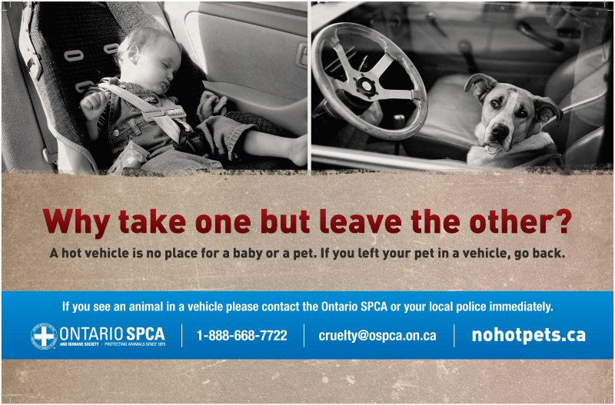

- Who is the sponsor? (1 mark)
- drivers
- local police
- Ontario SPCA
- parents
- What is the purpose of the visual? (1 mark)
- Criticize those who leave children and animals alone in cars.
- Encourage people to be responsible parents and pet owners.
- Prevent parents from leaving children unattended.
- Reinforce that children are more important than animals.
- What is the purpose of having the two pictures side by side? (1 mark)
- create juxtaposition
- establish focal point
- highlight background
- illustrate proportion
- What mood is created in the visual? (1 mark)
- content
- hostile
- optimistic
- serious
Constructed Response
- With specific references, explain how two visual elements contribute to the overall message of the visual. (6 marks)

